 | Data of the document
Student A, Student B, Student C | Author
V1 | Document version
dd.mm.yyyy | Release date

System Specifications
ASTech Student Tournament 2020
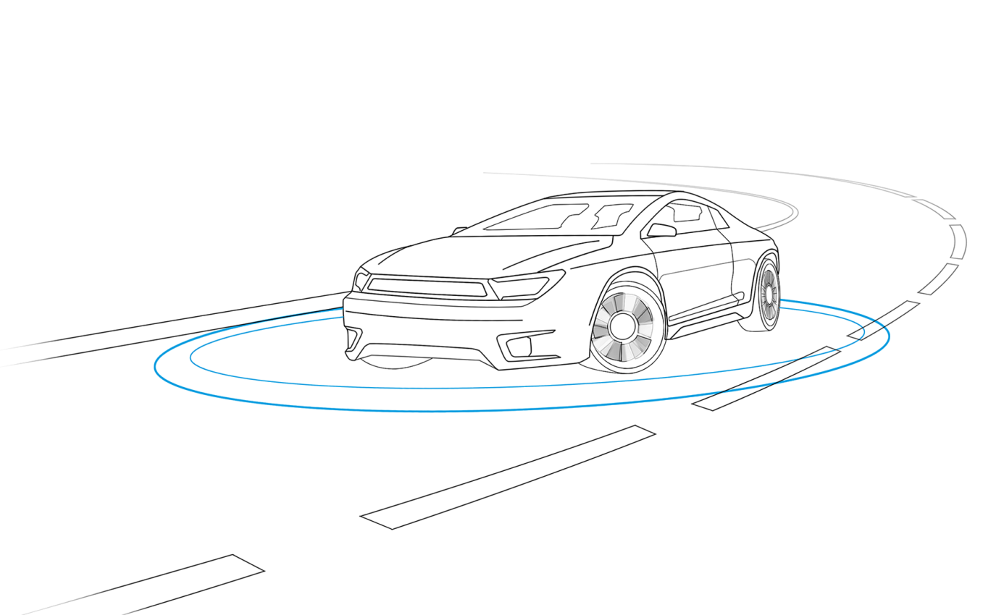
Document history

Version | Date | Author (department) | Description of change
Table of Content
1 Scope 4
2 System Specifications 4
2.1 System Architecture 4
2.1.1 Hardware Architectural Design 4
2.1.2 Functional Architecture 5
2.2 Functional Block Description 5
2.3 Input – Output Description 5
2.4 Test Specification 5

References
Author. Book / Paper / Article. Publisher, Year.
List of Abbreviations
Abbreviation | Description
e.g. ROS | Robot Operating System

Scope
The text marked in yellow is just an example. Please replace it in this document with your own information.
The usage of this template is recommended for the documentation of defined requirements, test specifications etc. However, the use of this template is not compulsory.
Following sections are an exemplary representation in the template’s structure.

System Specifications
The system specifications should describe the functional and non-functional requirements of the system.
If changes are required in the course of development of the overall system, the system specifications shall be adapted/updated at first.

System Architecture
The complete system architecture gives an overview of system’s hardware design and its functional structure. Additional information regarding the system architecture can be added here.

Hardware Architectural Design
Following figure gives an example of a possible hardware architectural design. Within this section you should describe the hardware architectural design which gives an overview of how the components are all connected together.
Which components are connected to the Arduino UNO and which are connected to the Raspberry Pi board?
How are the two boards connected with each other?
Which is the board that is powered supplied? Etc.
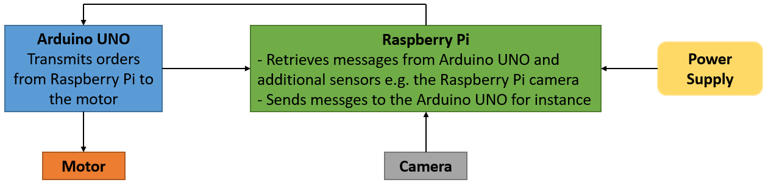
Figure 1: Hardware Design
It is however recommended to increase the level of detail by creating a schematic using tools like: Orcad, Eagle, Proteus, LTspice etc.

Functional Architecture
The functional architecture defines the possible sub-systems/functions and how these operate together to fulfill the system requirements.
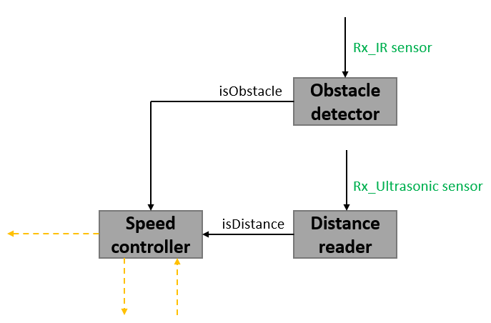
Figure 2: Functional architecture example

Functional Block Description
This section describes the functionality of every block defined in the functional architecture.

Input – Output Description
This section should describe the inputs and outputs of every functional block.

Test Specification
Functional tests can be specified as given in Table 1.
The primary components of a test case are:
- Test Case ID: The test case should have a name or an ID that is self-explanatory.
- Test Case Description: The description should tell the tester what they are going to test
- Pre-Conditions: Any preconditions that must be met prior to the test being executed should be included here.
- Test Case Steps: The test case steps should include necessary data and information on how to execute the test. The steps should be clear and brief, without leaving out essential facts.
- Expected Result: The expected results should tell the tester what they should expect from test steps.
- Actual Result: It specifies how the function actually behaved while the test cases were being executed.
- Comments: Additional comments as well as screenshots can be used by the tester to specify what exactly has been included in the test.
Test Case ID | Test Case Description | Pre-Conditions | Test Case Steps | Expected Result | Actual Result | Comments
TC_1 | Static object detection test with ultrasonic sensor. Assumption for this example is that the ultrasonic sensor detects an object placed at max. 1.5m in front. | - Target-object is placed 2 meters in front of the Ego-vehicle  - Target-object is static  - Ego-vehicle is standing still  - Ego-vehicle’s motor is power supplied  - Ultrasonic sensor is turned on  - etc. | - Ego-vehicle starts driving forward with v m/s  - Check if object is detected and distance returned every 0.5m between 2m and 1m | - When Ego-vehicle is 2 meters away from the target, no object is detected  - When Ego-vehicle is 1.5 meters away from the target, the object is detected and returned distance is 1.5m (± defined tolerance)  - When Ego-vehicle is 1m away from the target, the object is detected and returned distance is 1m (± defined tolerance) | - Ego-vehicle is 2m away, no object detected OK  - Ego-vehicle is 1.5m away, no object detected NOK  - Ego-vehicle is 1m away, object detected and returned distance is 0.95m OK
Table 1: Functional test specification

